Name:________________________________

USING A GRADUATED CYLINDER
A graduated cylinder measures liquid volume. Different graduated cylinders have different scales on them. You must consider the scale being used. Also, you must consider the meniscus! A meniscus is the curve in the upper part water that isn’t moving. You always measure liquid in a graduated cylinder from the BOTTOM of the curve!

What volume is shown on each of the following graduated cylinders?

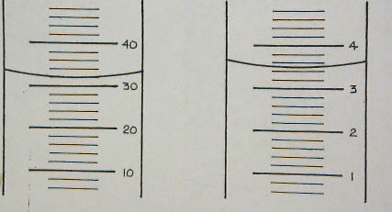

a)_______________ b)_____________ c)_________________ d)_________________

Now, draw in the meniscus for each of the following graduated cylinder volumes!

Measuring Liquid Volume with a Graduated Cylinder

Part 1: Observations Table: In the space below, draw your results. Be sure to include the COLOR and approximate height of each liquid!

A B C D E F

Part 2: Defense! In the space below, defend your results….justify WHY you think you have the correct answer!

Part 3: Conclusion: In the space below, write a conclusion paragraph about this lab. Be sure to explain WHAT you learned, whether or not you got accurate results, and WHY.

Measuring Liquid Volume with a Graduated Cylinder

Purpose:

To develop skill in measuring with a graduated cylinder
To use the metric system in measuring volume
To practice following directions and taking accurate measurements in the lab

Materials:

Red, blue, and yellow food coloring test tube stand
Water 50 mL graduated cylinder
3 beakers/cups 6 test tubes
labels for test tubes and beakers

Procedure:

- Label each test tube A, B, C, D, E, or F
- Fill three beakers with water. Label them beaker 1, 2, or 3
  - Add 10 drops of red food coloring to beaker 1
  - Add 10 drops of blue food coloring to beaker 2
  - Add 10 drops of yellow food coloring to beaker 3
- Measure 19 mL of red water from beaker 1 and pour it into test tube A
- Measure 18 mL of yellow water from beaker 3 and pour it into test tube C
- Measure 18 mL of blue water from beaker 2 and pour it into test tube E
- From test tube C, measure out 4 mL and pour it into test tube D
- From test tube E, measure out 7 mL and puor it into test tube D. Mix.
- Measure 4 mL from the beaker of blue water and add it to test tube F.
- Measure 7 mL from the beaker of red water and add it to test tube F. Mix.
- Measure 8 mL of water from test tube A and pour it into test tube B.
- Measure 3 mL out of test tube C and pour it into test tube B. Mix.

Results:

On your lab sheet, complete the observations table of your results for your group (Part 1). Also, defend your results (Part 2).

Group Discussion:

Wait quietly for all groups to finish. Participate in the whole group discussion about the groups’ findings.

Conclusion:

On the same paper as your observations table, write a good conclusion paragraph.

